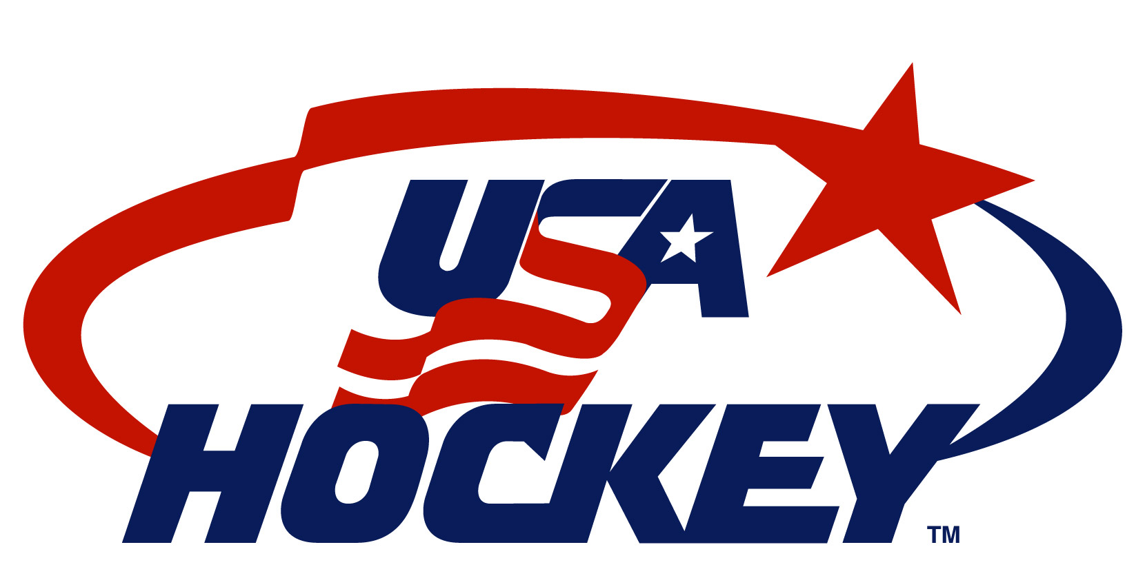
NATIONAL TEAM DEVELOPMENT PROGRAM
GOALTENDER DRILLS

AYERS ON ICE RECOVERY
Drill Description:

NOTE: Net is placed against boards. The goaltender starts in stance in the middle of the top of the crease. Shooter (S1) begins three feet above the top of the crease in line with the post.

On Coach’s Signal:
Goaltender drops into half butterfly towards the side that S1 is standing, at the same time; S1 shoots a puck off the back of the boards. The goaltender makes a quick on ice recovery towards the post, while S1 controls the pass off the wall for a quick shot short side.

Repeat drill 2X on each side for a total of 4 reps.

Key Teaching Points:  - Goaltender leads with stick and gloves to eliminate shooter’s ability to get puck up on the short side.  - After extending leg to make 1st shot save, the goaltender needs to recover with the foot of the drive leg in front of the extended knee. This rotates goaltender on angle. While recovering, continue to keep the lead leg extended and flush on the ice in order to fill space. Weight should be placed on the inside edge of the drive leg. After pushing off with the inside edge of the outside leg the goaltender must bring the outside leg flush onto the ice. | S1  G

